Contact Us
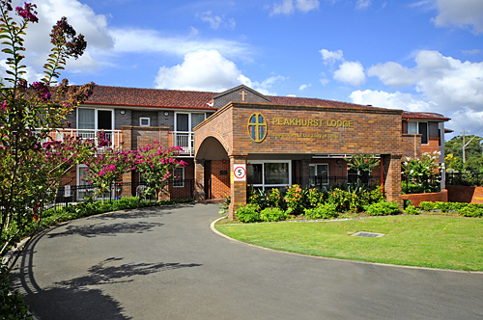
HEAD OFFICE Address: The Sisters of Our Lady of China Aged Care Services
16 – 18 Henry Lawson Drive
Peakhurst NSW 2210
Phone: (02) 9153 0965 (Administration Office) or (02) 9534 3073 (Operating Manager)
Fax: (02) 9153 9261
Email: info@ourladyofchina.org.au

